

MATHEMATICS
APPLICATIONS

Test 1 – Data Analysis and Linear Models

Chapters 1 and 2
Semester 1 2018

Section One - Calculator Free

Time allowed for this section
Working time for this section: 25 minutes
Marks available: 27 marks

Material required/recommended for this section

To be provided by the supervisor
This Question/Answer booklet
Formula sheet

To be provided by the candidate
Standard items: pens, pencils, pencil sharpener, eraser, correction fluid, ruler, highlighters

Special items: Nil

Important note to candidates
No other items may be used in this section of the examination. It is your responsibility to ensure that you do not have any unauthorised notes or other items of a non-personal nature in the examination room. If you have any unauthorised material with you, hand it to the supervisor before reading any further.

- (7 marks)
Before a fitness campaign at a high school, 50 students were chosen at random from each year group and asked the following questions:
Question 1: Which one of the following modes of transport do you use to travel to and from school?
Category A: walking/cycling
Category B: public transport
Category C: private car
Question 2: Which year group are you in?
The campaign organisers wished to determine whether age group affected the students’ likelihood of walking/cycling to and from school.
The results of the survey are shown in the table below.
 | Category A | Category B | Category C | Total
Year 7 | 19 |  | 20 | 50
Year 8 | 12 | 17 | 21 | 50
Year 9 | 13 | 14 | 23 | 50
Year 10 | 11 |  | 21
Year 11 | 10 | 15 | 25 | 50
Year 12 | 8 | 17 | 25 | 50
Total | 73 |  | 135 | 300
- Complete the missing entries in the table above. [2]
- Compare the percentages of students in Year 7 and Year 12 who use Category A as a mode of transport and comment on your results. [2]

The data given in the table in part a. have been displayed as a divided column graph below.
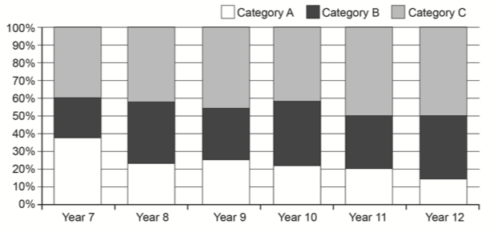
- Using the graph above or another method, comment on:
i. the association between ‘Year group’ and ‘Category A’. [1]

ii. the association between ‘Year group’ and ‘Category C’. [1]

iii. the association between ‘Category A’ and ‘Category B and C combined’. [1]

- (15 marks)
The marks for Chemistry and Physics tests (out of 10) were recorded in the table below for 7 students:
 | Chemistry (x) | 3 | 4 | 5 | 6 | 7 | 9 | 9
 | Physics (y) | 2 | 4.5 | 4 | 6 | Absent | 7 | 8
- Draw a scatterplot to represent this information. [3]
- Describe the strength and direction of the association. [2]

- Draw the line of best fit ‘by eye’ and hence estimate a Physics mark for the student who was unable to sit that test (to the nearest half mark). [2]

The ‘Line of Best Fit’ equation for the association is: y = 0.8x + 0.4
- Complete the table of residuals to 1 d.p. [4]
 | Chemistry (x) | 3 | 4 | 5 | 6 | 9 | 9
 | Physics (y) | 2 | 4.5 | 4 | 6 | 7 | 8
 | Predicted Physics | 2.8 |  |  |  |  | 7.6
 | Residual | -0.8 |  |  |  |  | 0.4
- Draw a residual plot. [2]
- Using the residual plot as a reference, decide if the data being investigated is linear or non-linear. [2]

- (5 marks)
The worldwide consumption of coal (in billion tonnes of oil equivalent, BTOE) is shown in the graph below from 1965 until 2010.
- Add a trend line, by eye, to the scatterplot. [1]
- Estimate the worldwide consumption of coal in

(i) 1960. [1]

(ii) 2030. [1]

- Which estimate in (c) is more reliable? Explain your reasoning. [2]

End of Section One

